**Thread**

A thread is an independent path of execution within a program.

**Multithreading**

Multithreading refers to two or more tasks executing concurrently within a single program.Many **threads** can run concurrently within a program. Every **thread in Java** is created and controlled by the **java**.lang.**Thread** class.

**Syntax**

**Thread t = new Thread**

**t.start();**

Many threads can run concurrently within a program and these threads can run concurrently, either asynchronously or synchronously.. Every thread in Java is created and controlled by the **java.lang.Thread class**.

**Advantages**

* Threads are lightweight compared to processes
* Threads share the same address space and therefore can share both data and code
* Context switching between threads is usually less expensive than between processes
* Cost of thread intercommunication is relatively low that that of process intercommunication
* Threads allow different tasks to be performed concurrently.

The following figure shows the methods that are members of the Object and Thread Class.

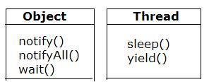

**THREAD CREATION**

There are two ways to create thread in java;

* Implement the Runnable interface (java.lang.Runnable)
* By Extending the Thread class (java.lang.Thread)